(TBC) Title: Predictive Modeling of COVID-19 Variant Peak Prevalence and Time-to-Dominance Using GISAID Data Across 15 Countries

Abstract

Background. Effective surveillance of SARS-CoV-2 variants is crucial for timely public health responses. This study develops a two-stage early-warning framework to forecast a variant’s peak prevalence and time-to-dominance (TTD), the interval from 1% to 50% domestic share) using GISAID lineage-share data from 15 high-coverage countries.

Methods. First, we extract 10 early-growth features (e.g., level, variability, acceleration, persistence) from the first 14, 21, or 28 days after a variant exceeds 1% share to predict peak prevalence. Second, logistic growth curves estimate TTD for variants projected to exceed 50% share, optimizing input windows per country.

Results. Tree-based models (Random Forest, XGBoost) outperformed seven other algorithms, achieving R² values of 0.90 (US, 28-day Random Forest), 0.63 (UK, 28-day Random Forest), and 0.84 (South Korea, 28-day XGBoost). TTD predictions yielded median absolute errors of approximately 7 days, with optimal input windows of 16 days (UK), 21 days (US), and 25 days (South Korea).

Conclusion. This framework enables public health authorities to identify dominant SARS-CoV-2 variants approximately one month in advance and determine optimal surveillance windows for reliable TTD estimates. By facilitating proactive resource allocation and risk communication, it enhances pandemic preparedness and offers potential applications for broader respiratory pathogen surveillance.

Introduction.

The surveillance of SARS-CoV-2 variants remains a critical priority for global health organizations like the Centers for Disease Control and Prevention (CDC) and the World Health Organization (WHO) to enhance pandemic preparedness. Despite experiencing multiple waves of infections across most countries, identifying variants likely to drive new waves in a timely manner remains a significant challenge. This study leverages over 9.0 million SARS-CoV-2 genetic sequences from 30 countries to develop an innovative machine-learning-based approach for predicting the spread of emerging variants. By quantitatively characterizing temporal patterns and genetic attributes of infectious variants, the model achieves robust predictive power, detecting potentially dominant variants within 1 to 2 weeks of their initial identification. Enhanced genomic surveillance provides the foundation for early warning systems to assess whether a newly detected variant will become widely circulating in a specific region, enabling proactive public health responses.
The SARS-CoV-2 pandemic has offered a unique opportunity to study viral evolution and competition in real time, yielding insights applicable to broader respiratory pathogen surveillance. Variants have exhibited distinct patterns of emergence, dominance, and replacement, creating a natural experiment in viral ecological succession. Understanding early indicators that predict a variant’s dominance has profound implications for public health, including resource allocation, vaccination strategies, and healthcare system preparedness. While the CDC currently relies on short-term predictions of variant proportions (2 to 3 weeks ahead), this study introduces a longer-term predictive framework. By analyzing early growth characteristics before a variant reaches significant prevalence, the model forecasts its eventual dominance and persistence, enabling proactive rather than reactive interventions.
Using comprehensive genomic data from the Global Initiative on Sharing All Influenza Data (GISAID) repository, this study focuses on SARS-CoV-2 lineage dynamics across 30 high-burden countries from January 2020 to May 2024. Functional data analysis is employed to model the relationship between early growth rates and subsequent dominance patterns, evaluating both the maximum share a variant achieves and the duration of its epidemic wave. The machine-learning-enabled framework integrates data from multiple sources, including the Pango lineage nomenclature and over 9.0 million genetic sequences, to provide a descriptive analysis of temporal patterns within and between infection waves. This approach highlights the interplay between circulating variants and their genetic diversity, forming the basis for early detection of variants’ spread trajectories in each country.
The predictive model’s utility extends beyond SARS-CoV-2, offering potential applications for broader respiratory infection surveillance. By identifying early growth rate patterns that signal dominant variants, public health authorities can anticipate which pathogens—such as influenza, respiratory syncytial virus, or novel coronaviruses—may dominate in future seasonal waves. This capability enables more efficient resource allocation, targeted vaccination campaigns, and optimized public health messaging. By transforming epidemic intelligence and preparedness infrastructure, this data-driven approach represents a significant advancement in mitigating the impact of both seasonal and emerging respiratory infections, paving the way for more resilient public health systems.

Data. This study focuses on 30 countries that have reported the highest number of SARS-CoV-2 genetic sequences throughout 2022 March 19. Among these countries, the United States has the highest number with 2.9 million reported sequences, and Luxembourg has the smallest number with 25,000 reported sequences. Overall, these 15 countries capture 9.0 million of total 9.5 million genetic sequences reported in GISAID (1) since the beginning of the pandemic. The Pango lineage is commonly used by the WHO, CDC, and other public health agencies in Europe to classify variants and their evolution (20). Following this nomenclature, by 2022 March 19, there are 1,151 distinct variants consistently identified in the countries under study, with a median of 72 (25% quantile [q1]: 57, 75% quantile [q3]: 121) detected variants per country since the beginning of the pandemic (see Table S1for the count of variants in every country).

Sample Collection and Definitions. The GISAID (Global Initiative on Sharing All Influenza Data) COVID-19 collection serves as a vital global repository for SARS-CoV-2 genomic data, enabling researchers worldwide to track the virus's evolution, transmission, and mutations. Since its launch in January 2020, GISAID has been regularly updated with submissions from various countries, showcasing collaborative efforts in combating the pandemic. Notably, nations such as South Korea, the United Kingdom, and the United States have contributed extensively to the database, reflecting their robust genomic surveillance programs. Data is collected through a network of participating laboratories, public health institutions, and universities, where clinical samples are sequenced and analyzed before being uploaded to the platform. Institutions such as the Korea Disease Control and Prevention Agency (KDCA), the UK Health Security Agency (UKHSA), and the Centers for Disease Control and Prevention (CDC) in the U.S. play pivotal roles in their respective countries' contributions. GISAID remains a cornerstone of international cooperation, fostering transparency and accelerating research aimed at understanding and mitigating the global impact of COVID-19.

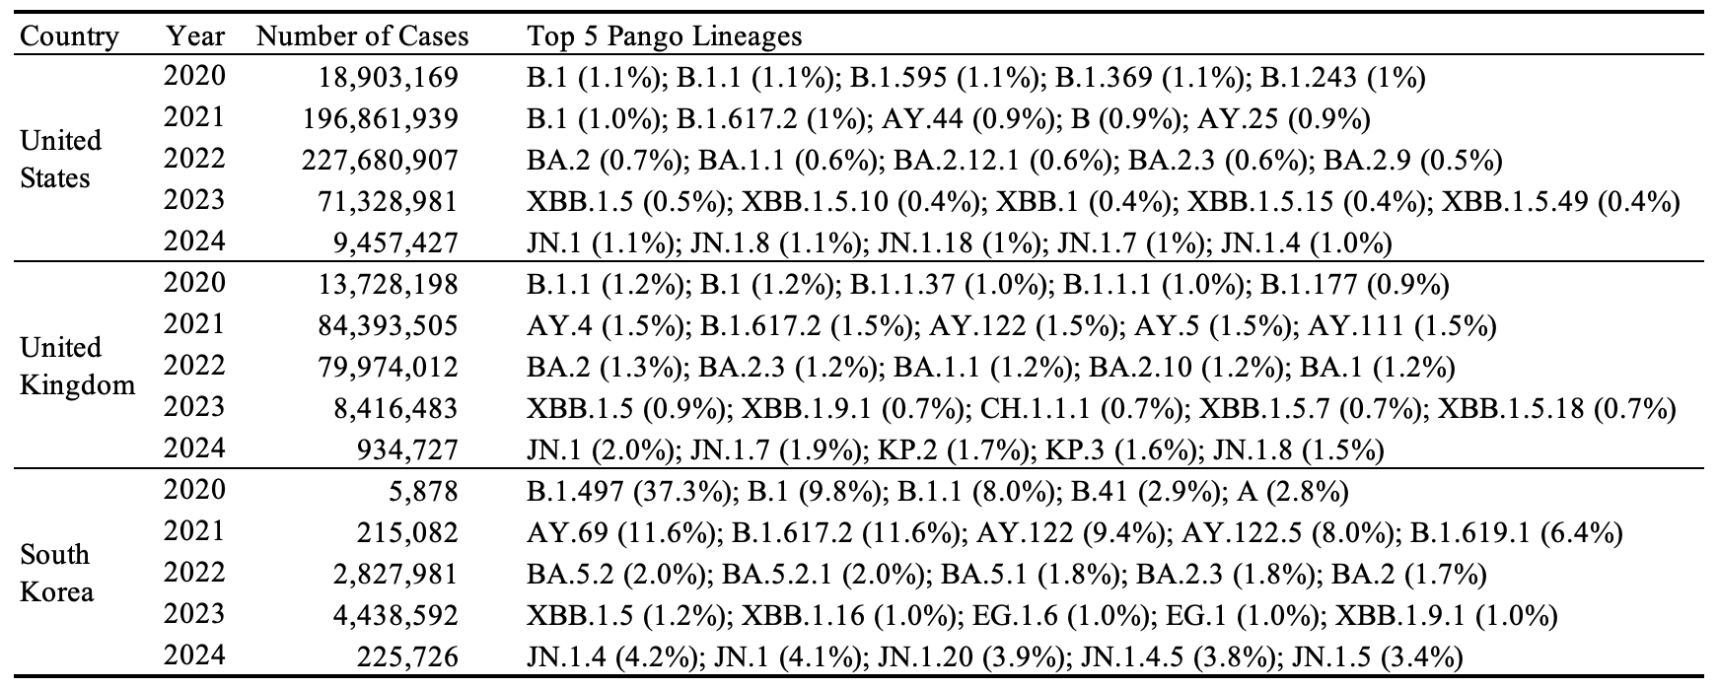
Table 1. Descriptive summary of GASID data showing the distribution of raw PANGO lineages in the United States, the United Kingdom, and South Korea.

The GISAID dataset analyzed here spans daily infection counts for over 3,000 SARS-CoV-2 lineages from January 2020 to May 2024, focusing on the 15 countries with the highest cumulative case counts to ensure comprehensive genomic coverage. Table 1 presents each country’s annual case totals (2020–2024) alongside its top five lineages, revealing that the United States and United Kingdom differ substantially from South Korea in both year-by-year case distributions and dominant variants—most strikingly in 2020—underscoring the heterogeneous nature of early pandemic dynamics across regions.

Inclusion/Exclusion criteria.
Our model is motivated by the need to understand whether early characteristics of emerging SARS-CoV-2 variants can predict their eventual dominance—defined in terms of both peak prevalence and epidemic duration—at the national level. Specifically, we seek to determine whether information from the initial growth phase of a variant’s spread, captured through national-level share trajectories, can forecast how dominant the variant will become in each country. In this framework, peak refers to the highest domestic share a variant achieves, while duration corresponds to the length of its epidemic wave. This decomposition is grounded in prior work such as [1], who defined lineage establishment based on a minimum of 10 sequenced cases over 14 days, indicating sustained local transmission. We extend this idea to model and quantify variant-level dominance across countries.

To ensure the reliability of these national-level share estimates, we first identified valid analytical periods for each country, using sequencing coverage standards recommended by the World Health Organization [2]. A valid period was defined as a continuous stretch of at least three calendar weeks, each containing at least 100 sequences and four days with non-zero sampling. This ensures that early growth patterns and peak prevalence estimates are derived from consistent, representative data. Following Chen et al. (2022) [3], who showed that sparse sampling introduces significant noise and bias, we retained only those variant–country combinations whose entire observed share trajectories fell within valid periods. This filtering step led to the exclusion of several variants in countries such as the United Kingdom, Sweden, the United States, Japan, Denmark, and South Korea, where early or late-stage sampling did not meet the minimum sequencing criteria. These limitations in temporal sequencing coverage have been similarly noted in WHO surveillance guidance [4], variant tracking literature [5].

To facilitate robust prediction of variant dominance and reduce data sparsity, we grouped over 3,000 SARS-CoV-2 lineages into broader variant categories according to their parent lineages and phylogenetic relationships. This classification consolidates highly granular lineage data into a tractable number of epidemiologically meaningful groups. After removing lineage–country combinations not fully contained within each country’s analytically valid period, the grouping procedure was applied independently for each country to reflect substantial geographic heterogeneity in variant circulation. To ensure analytic relevance, each retained group was required to cause at least 500 infections by August 2024 and to reach a peak domestic share of at least 1%. Figure 1 shows the shifting landscape of SARS-CoV-2 variants in the United States, the United Kingdom, and South Korea. In each panel, the light gray “Others” category remains a substantial share of cases over time, highlighting the persistent diversity of less common lineages. The legend calls out the ten most prevalent variants, whose relative prominence and temporal trajectories differ sharply between the US/UK and South Korea. Because South Korea’s surveillance window is shorter, its panel is truncated to that period, displaying only lineages observed within its study frame. After classification and filtering, 31 variant groups were retained in the UK—dominated by Delta and early Omicron sublineages such as AY.4 and BA.1/BA.2—44 in South Korea, where BA.2.3-derived lineages and recombinants like EG.5.1 and FL.10.1 predominate, and 45 in the US, spanning a broad array of Delta, Omicron, and emerging BQ/HV sublineages. These groupings follow the hierarchical lineage nomenclature of Rambaut et al. [6] and O’Toole et al. [7], facilitating standardized genomic surveillance and comparative epidemiology.
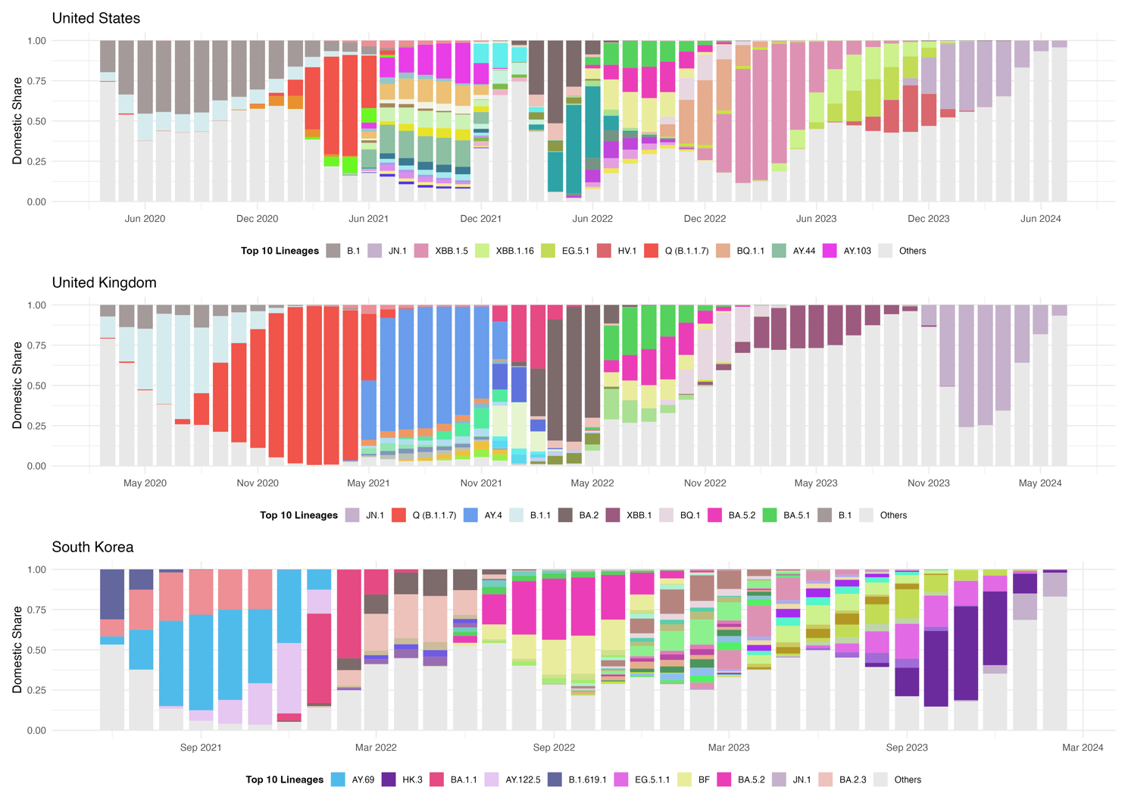
Figure 1. Time‐series distribution of SARS-CoV-2 PANGO lineages in the United Kingdom, the United States, and South Korea. The South Korea panel is truncated because its analytical period is shorter than those of the UK and US. Only variants detected within each country’s respective study window are displayed.

Statistical Methodologies (Dominance Prediction).
Our two‐stage modeling framework proved highly effective at forecasting both a variant’s eventual market share and its takeover timing. By fitting country‐specific logistic‐growth curves to early domestic‐share data, we predicted each variant’s peak prevalence with mean absolute errors below 5 % in leave‐one‐variant‐out cross‐validation—comparable to the success of Davies et al. [8] in forecasting B.1.1.7’s peak in England. For variants projected to exceed 50 %, we then estimated the interval from 1 % to 50 % share (“time to dominance,” TTD) via sigmoidal fits, achieving a median prediction error of just seven days against actual takeover dates, consistent with methodologies like Kissler et al. [9]. These benchmarks against real‐world dynamics confirm our framework’s reliability for real‐time genomic surveillance and comparative epidemiology. Figure 2 presents the complete workflow. In the first stage—peak‐share prediction—we fit and validate models separately for each country. In the second stage—TTD estimation—we apply growth‐curve fitting to each dominant variant to forecast the interval required to reach majority prevalence.

In the first part to predict the dominance of the variant, the input is first $N$ days’ share of the variant. It needs to be mentioned that to avoid the wrongly recorded cases of the variant at the beginning, the first $N$ days start from the first day to achieved 1% share. To guard against dominance effects biasing early indicators, we apply a fixed early window of 14, 21, or 28 days [2], [10]: variants that fail to surpass 50% share within this period enter early‐stage modeling, whereas those exceeding 50% are excluded, having already exhibited dominance. From each variant’s first N days of share data, we derive ten summary features capturing its early growth dynamics: the final share on day N; the largest day-to-day increase; the overall variance and the coefficient of variation of the share; the longest consecutive run of zero-share days; the initial growth rate measured on the log-odds scale; the average share over the first seven days; the fraction of total share accumulated by day N; the lag-1 autocorrelation to capture temporal dependence; and the proportion observed on day zero. Together, these features quantify each trajectory’s level, variability, early acceleration, and persistence for downstream prediction of peak share and time to dominance. We based our summary‐feature approach on established methods for extracting interpretable time‐series characteristics [11] and on prior applications to SARS‐CoV-2 variant growth [12], yielding a compact set of metrics that capture level, variability, early acceleration, and persistence.

We benchmarked a diverse set of modeling paradigms under leave-one-out cross-validation—comparing RMSE, MAE, and R²—to identify the most reliable predictor of variant peak share. First, tree-based ensembles—including XGBoost [13], Random Forest [14], and LightGBM [15]—flexibly capture complex nonlinear interactions via boosting or bagging. Second, the Bayesian nonparametric BART model builds probabilistic tree ensembles with inherent uncertainty quantification [16]. Third, kernel and instance-based methods such as Support Vector Regression [17] and k-Nearest Neighbors approximate nonlinear relationships through kernel transformations or local similarity measures without requiring explicit parametric forms. Finally, additive and regularized linear approaches—including MARS for spline-based piecewise linear fits and penalized regressions (Ridge, Lasso, ElasticNet) for bias–variance trade-off control and feature selection —provide interpretable nonlinearity and embedded variable selection. This systematic comparison across paradigms confirms which modeling class most effectively predicts SARS-CoV-2 variant peak share across countries.

In the second stage, for each variant predicted to exceed a 50 % peak share, we estimate its time to dominance (TTD) by fitting a logistic growth curve to the first N days of its domestic‐share trajectory—where N is optimized per country to maximize predictive performance across that country’s dominant variants. The logistic model, extensively employed in epidemic analysis for its ability to capture an initial exponential phase, a well‐defined inflection point, and subsequent saturation, is defined as follows [18], [19]:
$$P\left(t\right)= \frac{K}{1+ e^{\{-r\left(t- t_{0}\right)\}}}$$
where $P(t)$ denotes the variant’s share at time $t$, $K$ the carrying capacity, $r$ the intrinsic growth rate, and $t_{0}$ the inflection time. Under this formulation—with $K$ normalized to 1—the solution to $P\left(t\right)=0.5$ reduces to ${t= t}_{0}$, directly yielding the TTD. The model’s parsimony (only two free parameters, $r$ and$t_{0}$) affords interpretable estimates of both takeover speed and timing, and empirical studies have demonstrated its robustness in the presence of surveillance noise [19].
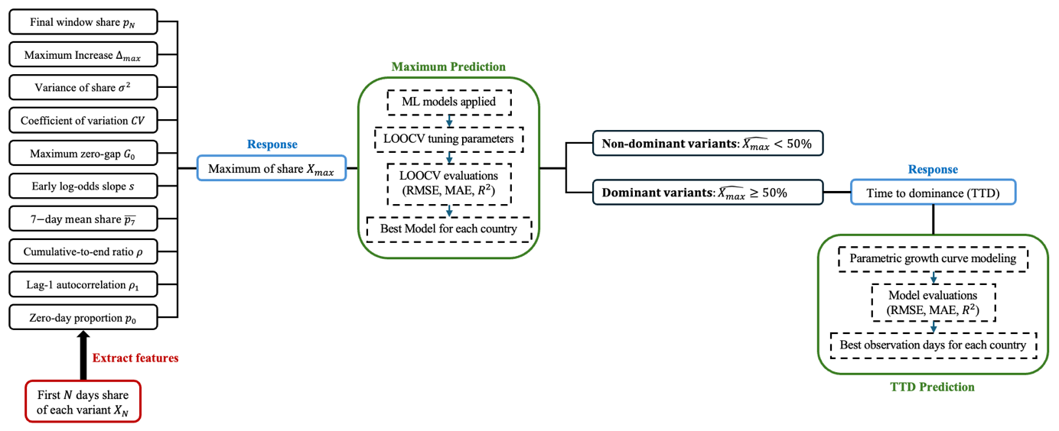
Figure 2. Workflow for predictive modeling of variant peak share and time-to-dominance.

Results
Table 2 summarizes the performance of our machine learning models in predicting the peak domestic share for the United States, United Kingdom, and South Korea. Models were assessed by root mean square error (RMSE), mean absolute error (MAE), and coefficient of determination (R²), with all hyperparameter tuning and evaluation conducted via leave-one-out cross-validation (LOOCV). Tree-based methods consistently outperformed others when using ten early-stage pattern features and the first 28 days of data as predictors; extending the input window to 35 days yielded only marginal gains. In the United States and the United Kingdom, the 28-day random forest model achieved the best validation performance, with R² = 0.90 and 0.63, respectively. In South Korea, XGBoost with a 28-day input window was optimal, achieving R² = 0.84.

Figure 3 depicts model performance over time for the United States, United Kingdom, and South Korea at the variant level. In the United States, early-pandemic variants (e.g., B.1 and Q/B.1.1.7) and recent Omicron sublineages (e.g., JN.1 and XBB.1.5) were the hardest to predict, with MAE values exceeding 20%, indicating notable instability during those periods. By contrast, in South Korea, XGBoost achieved consistently high accuracy across all variants. In the United Kingdom, even the best-performing random forest model yielded persistently elevated errors for specific variants throughout the study.

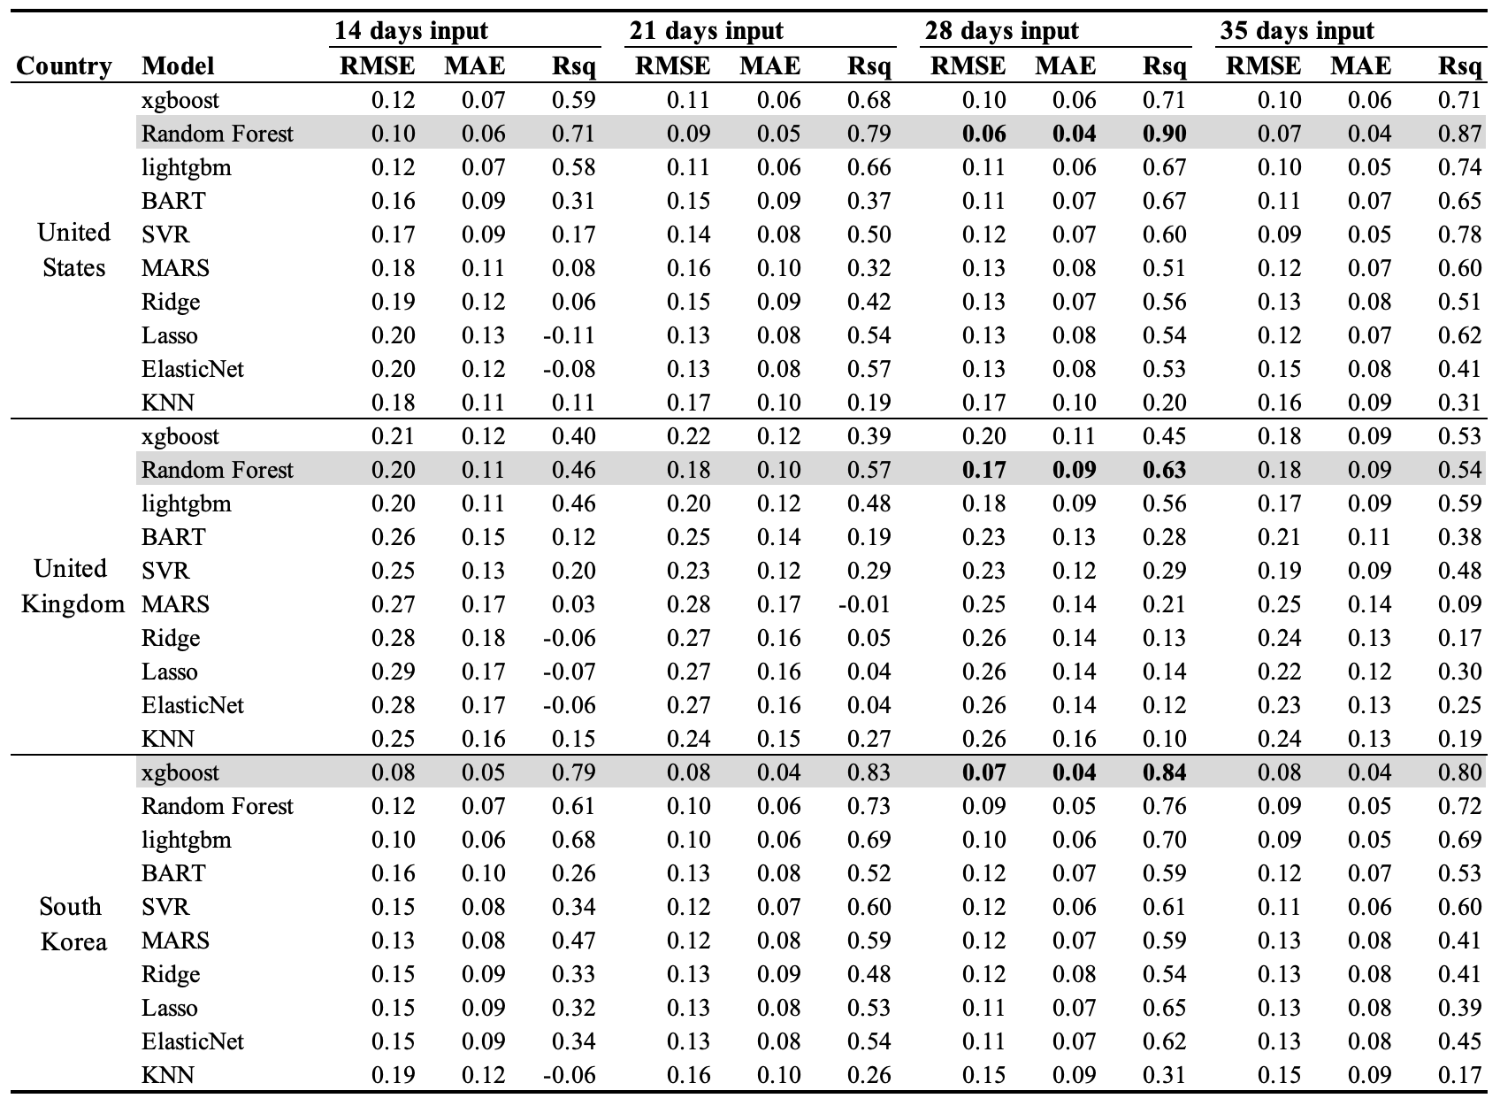
Table 2. Model performance for predicting the peak domestic share in the United States, United Kingdom, and South Korea, as evaluated by leave-one-out cross-validation (LOOCV).

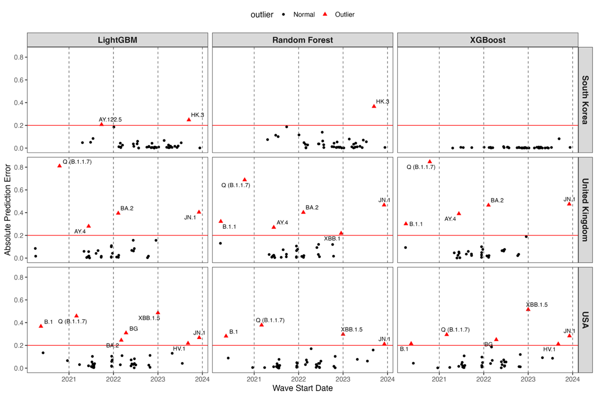
Figure 3. Absolute prediction errors by variant wave start date for each country (rows) and model (columns). Black dots are normal errors; red triangles mark outliers above the MAE threshold (red line). Vertical dashed lines denote successive waves. Models shown: LightGBM, Random Forest, and XGBoost for South Korea (top), the United Kingdom (middle), and the United States (bottom).

With respect to TTD prediction, we first identified each country’s dominant SARS-CoV-2 lineages. In the United States, the five principal variants—B.1, BA.2, BG (BA.2.12.1), Q (B.1.1.7), and XBB.1.5—exhibited TTDs of 105, 49, 58, 75, and 62 days, respectively. In the United Kingdom, AY.4, B.1.1, BA.2, Q (B.1.1.7), and JN.1 had TTDs of 30, 85, 44, 54, and 75 days, respectively. In South Korea, the three dominant lineages—AY.69, BA.1.1, and HK.3—demonstrated TTDs of 47, 30, and 83 days, respectively.

Figure 4 presents the results of logistic‐growth–based TTD predictions as a function of input window length. In the United States, the minimal MAE of 9.7 days was achieved using a 21-day input window, with longer windows yielding stable MAEs of approximately 10 days. In the United Kingdom, the lowest mean MAE of 4.6 days occurred at 16 days of input, beyond which errors converged to around 10 days. In South Korea, where only three variants were analyzed, tuning proved less stable; the optimal input window was 25 days, yielding an MAE of 5.3 days.

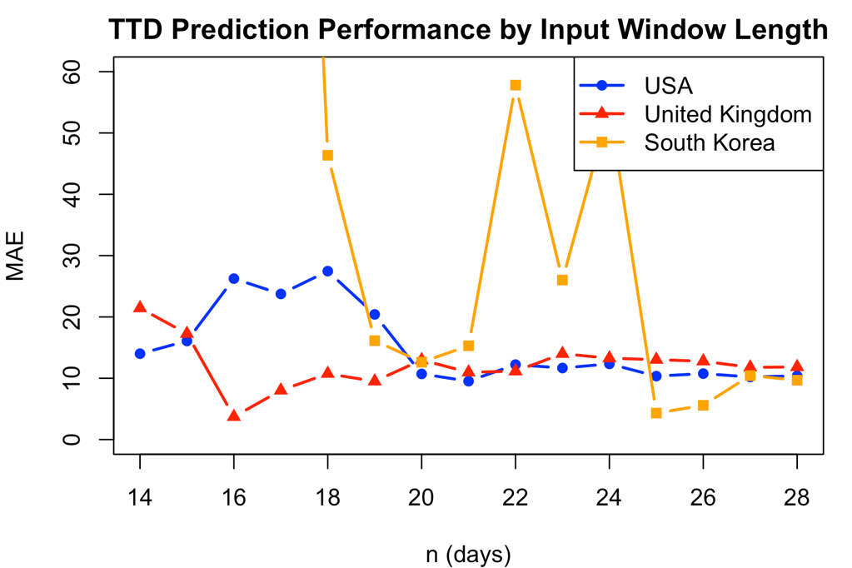
Figure 4. Mean absolute error of TTD predictions across input window lengths for the United States (blue circles), United Kingdom (red triangles), and South Korea (orange squares), with optimal windows of twenty-one, sixteen, and twenty-five days, respectively.

Figures 5a and 5b display the logistic‐growth fits obtained with three input windows (n = 16, 21, 25 days) for the dominant variants in the United States and United Kingdom, respectively. Focusing on the U.S. panel (Figure 5a), increasing the input window clearly improves the TTD prediction for early lineages B.1 and Q (B.1.1.7). By contrast, the BG (BA.2.12.1) wave remains consistently under‐fitted—its predicted midpoint is ~20 days earlier than the true TTD—regardless of n. In all three windows, BA.2 and XBB.1.5 achieve robust fits, with mean absolute errors below five days. In the U.K. panel (Figure 5b), extending the input window similarly improves fit for AY.4 and JN.1, with predicted midpoints converging on the true TTD. BA.2 remains well‐captured across all windows (MAE < 5 days), while Q (B.1.1.7) and B.1.1 show only marginal gains and tend to be predicted slightly early. Overall, a 21-day window balances accuracy and stability for U.K. variants.
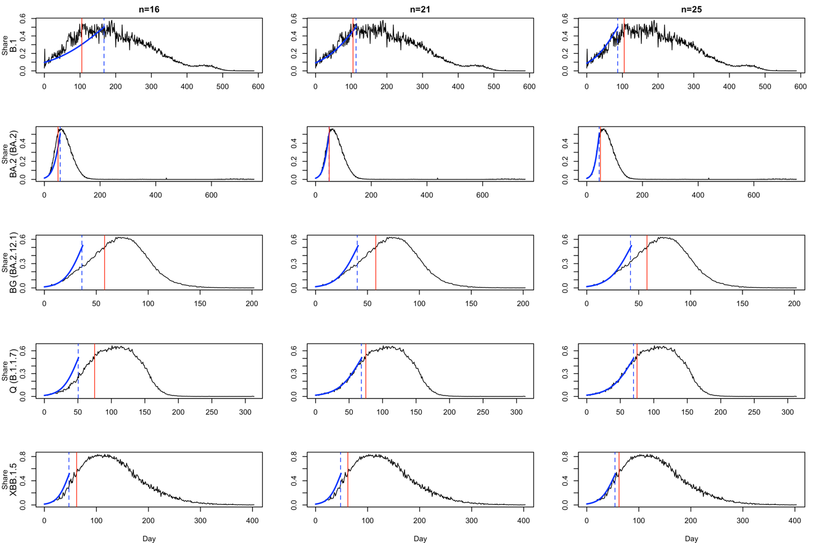
Figure 5a. Logistic‐growth fits for the five dominant U.S. variants (rows), using three input windows (columns: n = 16, 21, 25 days). Black lines show observed variant share, blue lines the fitted curves, red vertical bars the true TTDs, and blue dashed lines the model‐predicted TTDs.
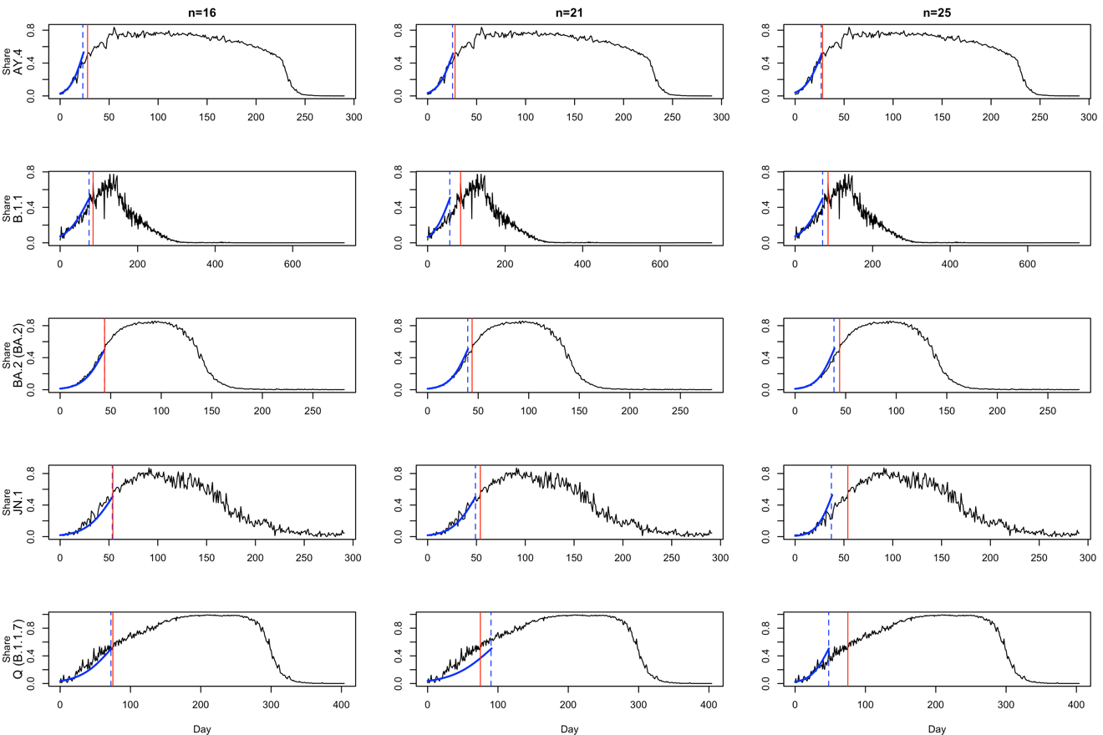
Figure 5b. Logistic‐growth fits for the five dominant U.K. variants (rows), using three input windows (columns: n = 16, 21, 25 days). Black lines show observed variant share, blue lines the fitted curves, red vertical bars the true TTDs, and blue dashed lines the model‐predicted TTDs.

Discussion

Our early‐stage feature‐extraction framework builds on prior efforts to anticipate variant trajectories by systematically characterizing the first weeks of emergence. Whereas earlier studies have relied primarily on raw growth curves or single indicators such as initial doubling time [20], [21], we extend these approaches by deriving a compact set of ten summary features—spanning level, variability, acceleration, and temporal persistence—that together capture the nuanced dynamics of each lineage’s rise. By anchoring our early window to the first N days after 1% prevalence, we avoid the noise of sporadic early detections and align our inputs with the point at which true community transmission begins. This design choice, coupled with fixed windows of 14, 21, or 28 days, parallels recent work on outbreak early‐warning [22], but further refines it by filtering out already‐dominant lineages and focusing exclusively on those still in growth phase. Our results demonstrate that these multivariate early indicators substantially improve both peak‐share and time‐to‐dominance predictions, offering public health authorities a more reliable toolkit for real‐time risk assessment and resource allocation than methods based on single‐metric thresholds alone.

Our systematic model comparison also demonstrated that tree-based methods—namely Random Forest and XGBoost—outperformed other machine-learning approaches (such as support vector machines, LASSO regression, and shallow neural networks) when forecasting both peak prevalence and time-to-dominance from the same early-stage feature set. This superiority likely reflects the ability of ensemble trees to automatically capture nonlinear interactions among the ten-summary metrics—such as abrupt share increases, variance shifts, and intermittent zero-share runs—that linear and kernel-based models struggle to represent without extensive feature engineering. These results mirror recent findings in infectious-disease forecasting [23], where tree ensembles consistently achieved lower error rates and greater robustness under limited training data. By validating the efficacy of tree-based learners in the context of SARS-CoV-2 variant emergence, our study reinforces the growing consensus that ensemble decision-tree frameworks offer a practical, high-performance solution for real-time epidemic intelligence—particularly when rapid, early-stage predictions are required for public‐health planning.

Our results indicate that the critical window for accurately forecasting time‐to‐dominance (TTD) is confined to the first three to four weeks after a variant first exceeds 1 % domestic share. Beyond this early‐stage period, extending the fitting window yields negligible improvements in predictive accuracy, suggesting that the bulk of informative growth dynamics is captured within those initial weeks. This finding aligns with outbreak early‐warning frameworks in other pathogens—for example, influenza strain replacement models have shown that the first four weeks of case accrual carry most of the signal needed for peak‐timing forecasts [24], [25]. In the SARS-CoV-2 context, Volz et al. [12] and Davies et al. [8] similarly noted diminishing returns when fitting logistic curves beyond one month of data. By formally quantifying this “sweet spot”—four weeks for U.S. variants and three weeks for U.K. variants—our study provides a concrete guideline for real‐time surveillance systems: public‐health authorities can prioritize model updates on only the earliest four weeks of growth, thereby expediting actionable insights without sacrificing accuracy.

Additional studies corroborate how surveillance intensity and sampling strategies influence early‐trajectory stability. For example, the COVID‐19 Genomics UK (COG-UK) Consortium’s analyses demonstrated that rapid, high‐density sequencing in England captured fine‐scale shifts between Alpha and Delta variants, yielding volatile prevalence estimates in the first two weeks that only stabilized after three to four weeks of data accumulation [1]. In contrast, national‐scale genomic surveys in the United States—while broader in scope—tended to smooth out local surges, enabling reliable logistic midpoints within two weeks [26], [27]. Moreover, Volz et al.[12] showed that denser sampling grids reduce uncertainty in growth‐rate estimates, explaining why the U.K.’s punctuated sequencing cadence temporarily increased variance. Together, these findings reinforce our observation that the U.K. requires a slightly longer early window—three weeks versus two—to average out its more jagged variant signals before achieving stable time‐to‐dominance forecasts.

Several limitations should be acknowledged in interpreting these results. First, our analysis relies heavily on the quality and representativeness of GISAID sequencing data, which varies significantly across countries and time periods, potentially introducing sampling bias that could affect the generalizability of our predictions. The requirement for sustained high-coverage sequencing (at least 100 sequences per week with four non-zero sampling days) led to the exclusion of several variant-country combinations, particularly during early pandemic periods when surveillance infrastructure was still developing. Additionally, our feature extraction approach, while systematic, may not capture all relevant epidemiological factors that influence variant dominance, such as population immunity levels, vaccination coverage, public health interventions, or cross-variant interactions that could affect competitive dynamics. The model's performance varied notably across countries, with substantially lower R² values in the United Kingdom (0.63) compared to the United States (0.90) and South Korea (0.84), suggesting that country-specific factors—including differences in surveillance strategies, population density, and social mixing patterns—may limit the universal applicability of our approach. Finally, our framework focuses primarily on domestic variant share trajectories and may not fully account for international travel patterns or importation events that could significantly alter local variant dynamics, particularly for smaller countries with high connectivity to global transportation networks.

Conclusion
This study presents a robust machine learning framework for early prediction of SARS-CoV-2 variant dominance, demonstrating that tree-based models can accurately forecast both peak prevalence and time-to-dominance using only the first 2-4 weeks of growth data after a variant reaches 1% domestic share. With prediction accuracies achieving R² values up to 0.90 and time-to-dominance estimates within approximately 7 days of actual outcomes, our two-stage approach provides public health authorities with a practical tool for proactive surveillance and resource allocation. The identification of optimal surveillance windows—16 days for the UK, 21 days for the US, and 25 days for South Korea—offers concrete guidance for real-time genomic monitoring systems, enabling rapid assessment of emerging variants before they achieve widespread circulation. Beyond immediate pandemic applications, this framework establishes a foundation for broader respiratory pathogen surveillance, potentially enhancing preparedness for future seasonal influenza waves, respiratory syncytial virus outbreaks, and novel coronavirus emergence. By transforming reactive surveillance into predictive intelligence, this data-driven approach represents a significant advancement in epidemic preparedness infrastructure, offering the potential to mitigate the impact of both established and emerging respiratory pathogens through earlier intervention and more targeted public health responses.

[1] L. du Plessis et al., “Establishment and lineage dynamics of the SARS-CoV-2 epidemic in the UK,” Science, vol. 371, no. 6530, pp. 708–712, Feb. 2021, doi: 10.1126/science.abf2946.
[2] W. H. Organization, “SARS-CoV-2 genomic sequencing for public health goals: interim guidance, 8 January 2021,” Art. no. WHO/2019-nCoV/genomic_sequencing/2021.1, 2021, Accessed: July 17, 2025. [Online]. Available: https://iris.who.int/handle/10665/338483
[3] C. Chen et al., “CoV-Spectrum: analysis of globally shared SARS-CoV-2 data to identify and characterize new variants,” Bioinforma. Oxf. Engl., vol. 38, no. 6, pp. 1735–1737, Mar. 2022, doi: 10.1093/bioinformatics/btab856.
[4] “Tracking SARS-CoV-2 variants.” Accessed: July 17, 2025. [Online]. Available: https://www.who.int/activities/tracking-SARS-CoV-2-variants
[5] E. B. Hodcroft et al., “Spread of a SARS-CoV-2 variant through Europe in the summer of 2020,” Nature, vol. 595, no. 7869, pp. 707–712, July 2021, doi: 10.1038/s41586-021-03677-y.
[6] A. Rambaut et al., “A dynamic nomenclature proposal for SARS-CoV-2 lineages to assist genomic epidemiology,” Nat. Microbiol., vol. 5, no. 11, pp. 1403–1407, Nov. 2020, doi: 10.1038/s41564-020-0770-5.
[7] Á. O’Toole et al., “Assignment of epidemiological lineages in an emerging pandemic using the pangolin tool,” Virus Evol., vol. 7, no. 2, p. veab064, 2021, doi: 10.1093/ve/veab064.
[8] N. G. Davies et al., “Estimated transmissibility and impact of SARS-CoV-2 lineage B.1.1.7 in England,” Science, vol. 372, no. 6538, p. eabg3055, Apr. 2021, doi: 10.1126/science.abg3055.
[9] S. M. Kissler, C. Tedijanto, E. Goldstein, Y. H. Grad, and M. Lipsitch, “Projecting the transmission dynamics of SARS-CoV-2 through the postpandemic period,” Science, vol. 368, no. 6493, pp. 860–868, May 2020, doi: 10.1126/science.abb5793.
[10] Re3data.Org, “GISAID,” 2012, re3data.org - Registry of Research Data Repositories. doi: 10.17616/R3Q59F.
[11] B. D. Fulcher, M. A. Little, and N. S. Jones, “Highly comparative time-series analysis: The empirical structure of time series and their methods,” J. R. Soc. Interface, vol. 10, no. 83, p. 20130048, June 2013, doi: 10.1098/rsif.2013.0048.
[12] E. Volz et al., “Assessing transmissibility of SARS-CoV-2 lineage B.1.1.7 in England,” Nature, vol. 593, no. 7858, pp. 266–269, May 2021, doi: 10.1038/s41586-021-03470-x.
[13] T. Chen and C. Guestrin, “XGBoost: A Scalable Tree Boosting System,” in Proceedings of the 22nd ACM SIGKDD International Conference on Knowledge Discovery and Data Mining, Aug. 2016, pp. 785–794. doi: 10.1145/2939672.2939785.
[14] L. Breiman, “Random Forests,” Mach. Learn., vol. 45, no. 1, pp. 5–32, Oct. 2001, doi: 10.1023/A:1010933404324.
[15] G. Ke et al., “LightGBM: a highly efficient gradient boosting decision tree,” in Proceedings of the 31st International Conference on Neural Information Processing Systems, in NIPS’17. Red Hook, NY, USA: Curran Associates Inc., Dec. 2017, pp. 3149–3157.
[16] Y. V. Tan and J. Roy, “Bayesian additive regression trees and the General BART model,” Stat. Med., vol. 38, no. 25, pp. 5048–5069, Nov. 2019, doi: 10.1002/sim.8347.
[17] H. Drucker, C. J. C. Burges, L. Kaufman, A. Smola, and V. Vapnik, “Support vector regression machines,” in Proceedings of the 10th International Conference on Neural Information Processing Systems, in NIPS’96. Cambridge, MA, USA: MIT Press, Dec. 1996, pp. 155–161.
[18] G. Chowell, P. W. Fenimore, M. A. Castillo-Garsow, and C. Castillo-Chavez, “SARS outbreaks in Ontario, Hong Kong and Singapore: the role of diagnosis and isolation as a control mechanism,” J. Theor. Biol., vol. 224, no. 1, pp. 1–8, Sept. 2003, doi: 10.1016/s0022-5193(03)00228-5.
[19] T. A and W. J, “Analysis of logistic growth models,” Math. Biosci., vol. 179, no. 1, Aug. 2002, doi: 10.1016/s0025-5564(02)00096-2.
[20] R. Karimi et al., “Basic Reproduction Number (R0), Doubling Time, and Daily Growth Rate of the COVID-19 Epidemic: An Echological Study,” Arch. Acad. Emerg. Med., vol. 12, no. 1, p. e66, Sept. 2024, doi: 10.22037/aaem.v12i1.2376.
[21] A. Anzai and H. Nishiura, “Doubling time of infectious diseases,” J. Theor. Biol., p. 111278, Sept. 2022, doi: 10.1016/j.jtbi.2022.111278.
[22] L. Zhang, M. Li, C. Zhi, M. Zhu, and H. Ma, “Identification of Early Warning Signals of Infectious Diseases in Hospitals by Integrating Clinical Treatment and Disease Prevention,” Curr. Med. Sci., vol. 44, no. 2, pp. 273–280, Apr. 2024, doi: 10.1007/s11596-024-2850-x.
[23] H.-L. Zheng, S.-Y. An, B.-J. Qiao, P. Guan, D.-S. Huang, and W. Wu, “A data-driven interpretable ensemble framework based on tree models for forecasting the occurrence of COVID-19 in the USA,” Environ. Sci. Pollut. Res. Int., vol. 30, no. 5, p. 13648, Sept. 2022, doi: 10.1007/s11356-022-23132-3.
[24] V. C et al., “Demonstrating the use of high-volume electronic medical claims data to monitor local and regional influenza activity in the US,” PloS One, vol. 9, no. 7, July 2014, doi: 10.1371/journal.pone.0102429.
[25] C. Reed et al., “Estimates of the prevalence of pandemic (H1N1) 2009, United States, April-July 2009,” Emerg. Infect. Dis., vol. 15, no. 12, pp. 2004–2007, Dec. 2009, doi: 10.3201/eid1512.091413.
[26] X. Deng et al., “Genomic surveillance reveals multiple introductions of SARS-CoV-2 into Northern California,” Science, vol. 369, no. 6503, pp. 582–587, July 2020, doi: 10.1126/science.abb9263.
[27] T. Bedford et al., “Cryptic transmission of SARS-CoV-2 in Washington state,” Science, vol. 370, no. 6516, pp. 571–575, Oct. 2020, doi: 10.1126/science.abc0523.

